

Practices for Secure Software Report

Table of Contents
Document Revision History 3
Client 3
Instructions 3
Developer 4
1. Algorithm Cipher 4
2. Certificate Generation 4
3. Deploy Cipher 4
4. Secure Communications 4
5. Secondary Testing 4
6. Functional Testing 4
7. Summary 4
8. Industry Standard Best Practices 4

Document Revision History

Version | Date | Author | Comments
1.0 | 8/12/26 | Spencer Reed | Detailed section 1
1.1 | 8/13/26 | Spencer Reed | Reviewed code; Implemented SHA-256 hash & added screenshot
1.2 | 8/14/26 | Spencer Reed | Generated certificate; Added screenshot
1.3 | 8/15/26 | Spencer Reed | Added screenshots for secure connection & TLS usage; Ran dependency check verification
2 | 8/16/26 | Spencer Reed | Final version – Completed remaining sections (Summary, Industry Best Practices)

Client



Instructions

Submit this completed practices for secure software report. Replace the bracketed text with the relevant information. You must document your process for writing secure communications and refactoring code that complies with software security testing protocols.

- Respond to the steps outlined below and include your findings.
- Respond using your own words. You may also choose to include images or supporting materials. If you include them, make certain to insert them in all the relevant locations in the document.
- Refer to the Project Two Guidelines and Rubric for more detailed instructions about each section of the template.

Developer
Spencer Reed

Algorithm Cipher

While I was asked to deploy a few things around security and data integrity and validation, the specifics of the instructions refers to an "encryption algorithm cipher," the mechanism deployed here is more precisely a cryptographic hash function, SHA-256. Unlike a reversible encryption cipher, a hash is a one-way function used to verify data integrity rather than to conceal data. SHA-256 is the appropriate choice for the checksum/file-verification requirement in this scenario.

SHA-256 cryptographic hash takes a set of data, regardless of size, and produces a 256-bit hash checksum, which can be used to check the integrity of any piece of data. If the data has been modified in any way a different checksum will be produced. The checksum that presents as random numbers and letters (which is actually the hex encoding of the hash) acts as a fingerprint of the data and any modification to the data will result in a different checksum – thus proving integrity of the data supplied. While these look random, they're actually a fixed-length hexadecimal string and very precise.

The bit size that SHA-256 gives us is, to date, the typical standard to utilize as it provides the best collision resistance. This means that there is no feasible way to find two inputs that produce the same digest (checksum), as there have been no known practical attacks against it. Unlike MD5 or SHA-1, which both have known practical collision attacks (SHA-1 was broken by the 2017 SHAttered attack), SHA-256 has no known feasible attack – producing a collision would require on the order of 2¹²⁸ operations by the birthday bound, which is computationally infeasible.

Unlike an encryption algorithm, a hash function is keyless and irreversible – there is no way to "de-hash" a checksum back to the original data, which is what makes it suitable for integrity verification rather than confidentiality. Asymmetric keys do appear in this project, but at the TLS layer: the self-signed certificate uses an RSA public/private keypair, and the certificate itself is signed using SHA256withRSA. During an HTTPS session, the RSA asymmetric keys establish the connection, after which a symmetric session key encrypts the actual data transfer.

Historically, we can discuss these going as far back as 1991 where MD5 was widely used until practical collision attacks broke it. This was then succeeded by SHA-1 in 1995 but became deprecated after theoretical weaknesses became the practical SHAttered collision in 2017. However, SHA-2 (which includes SHA-256) was published back in 2001 and is the current standard as specified in NIST's FIPS 180-4. SHA-3 was introduced in 2015 was suggested to be a standardized alternative that's built on a completely different internal construction (Keccak/sponge), as a hedge in case a structural weakness were ever found in SHA-2.

As it stands today, SHA-256 is the primary standard utilized until a repeatable collision is found. This is the workhorse hash across modern security – TLS certificates, code signing, blockchain, password storage schemas. On the quantum horizon, hash functions like SHA-256 are relatively resilient.

Certificate Generation
Insert a screenshot below of the CER file.

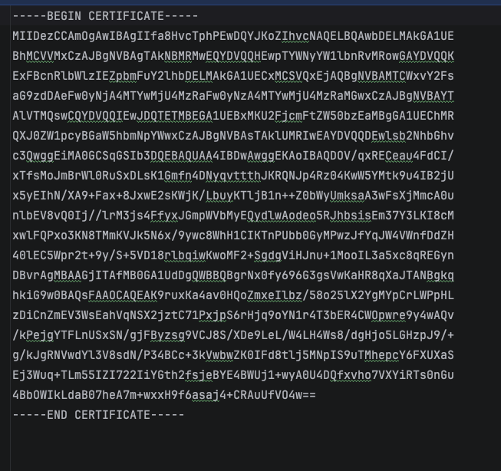

Deploy Cipher
Insert a screenshot below of the checksum verification.

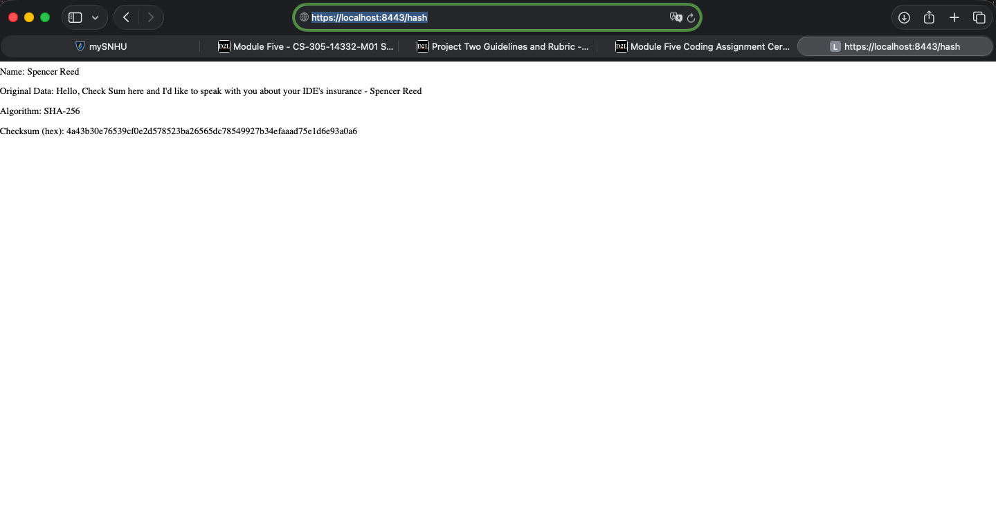

Secure Communications
Insert a screenshot below of the web browser that shows a secure webpage.



Secondary Testing
Insert screenshots below of the refactored code executed without errors and the dependency-check report.

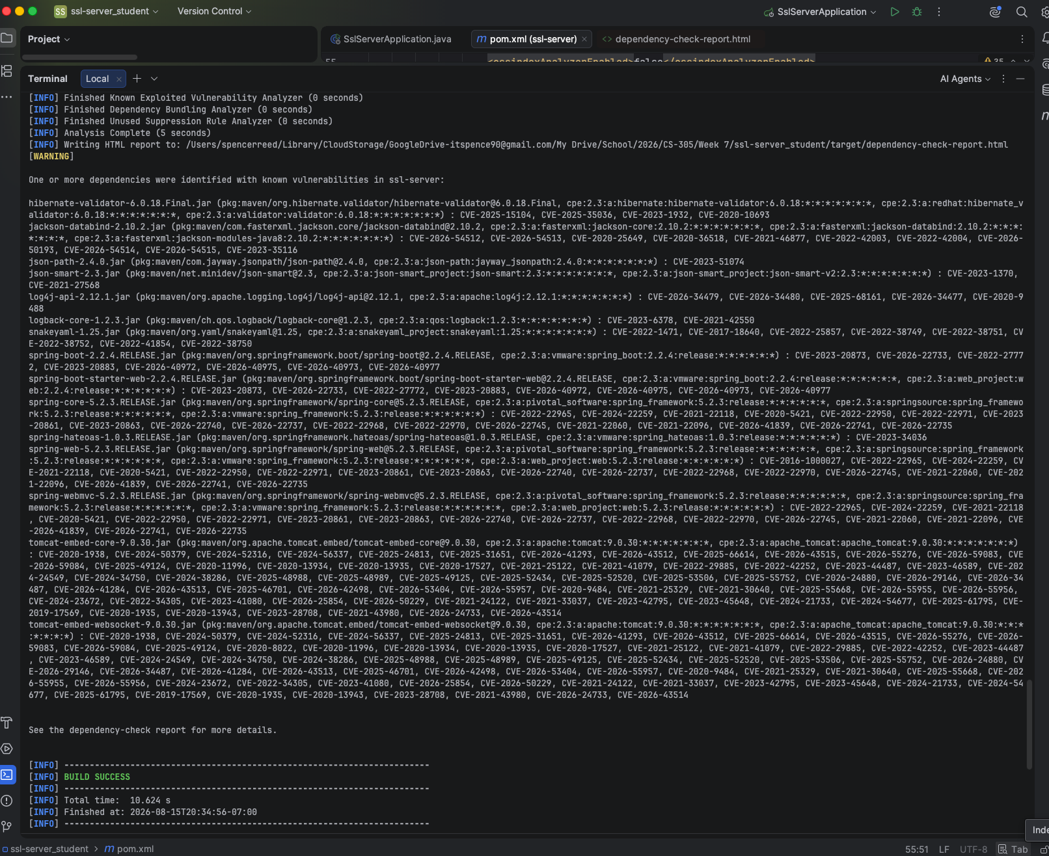

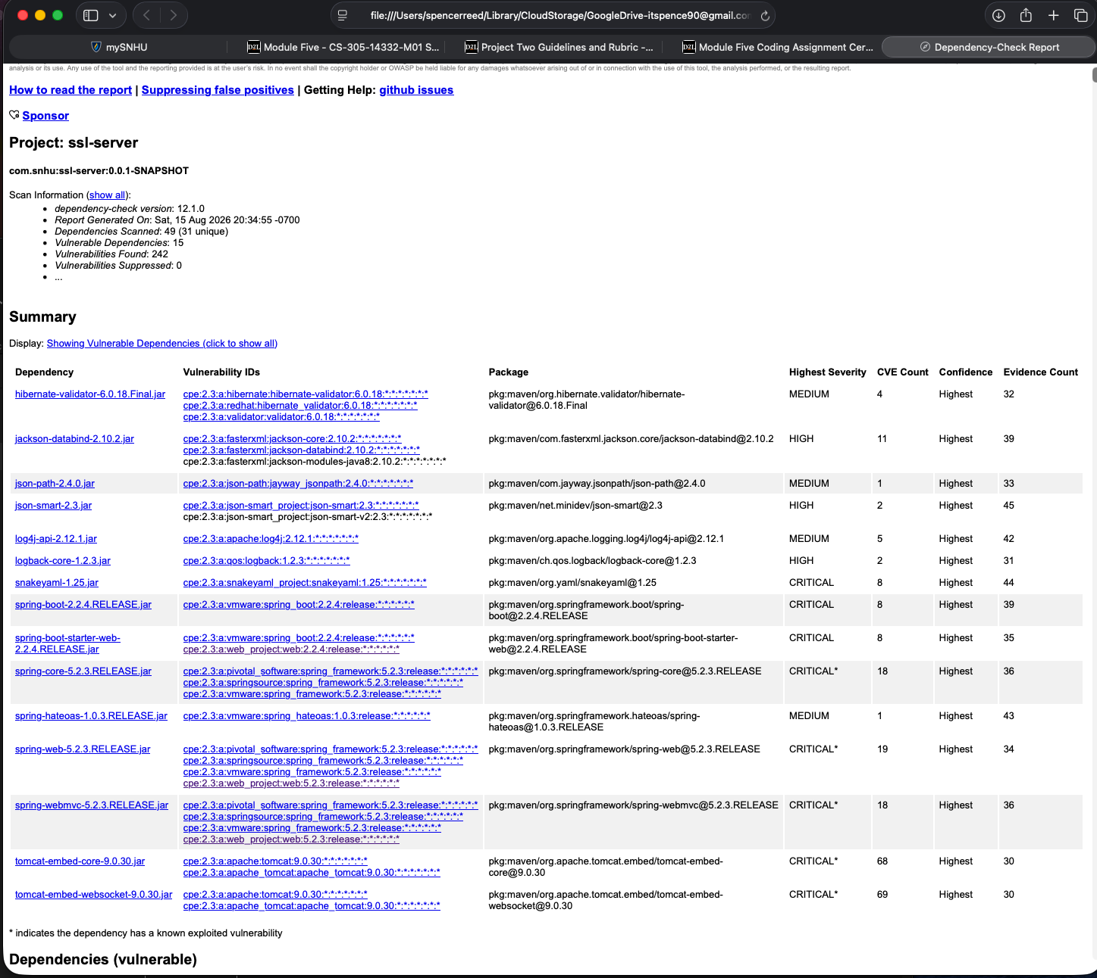

Functional Testing
Insert a screenshot below of the refactored code executed without errors.

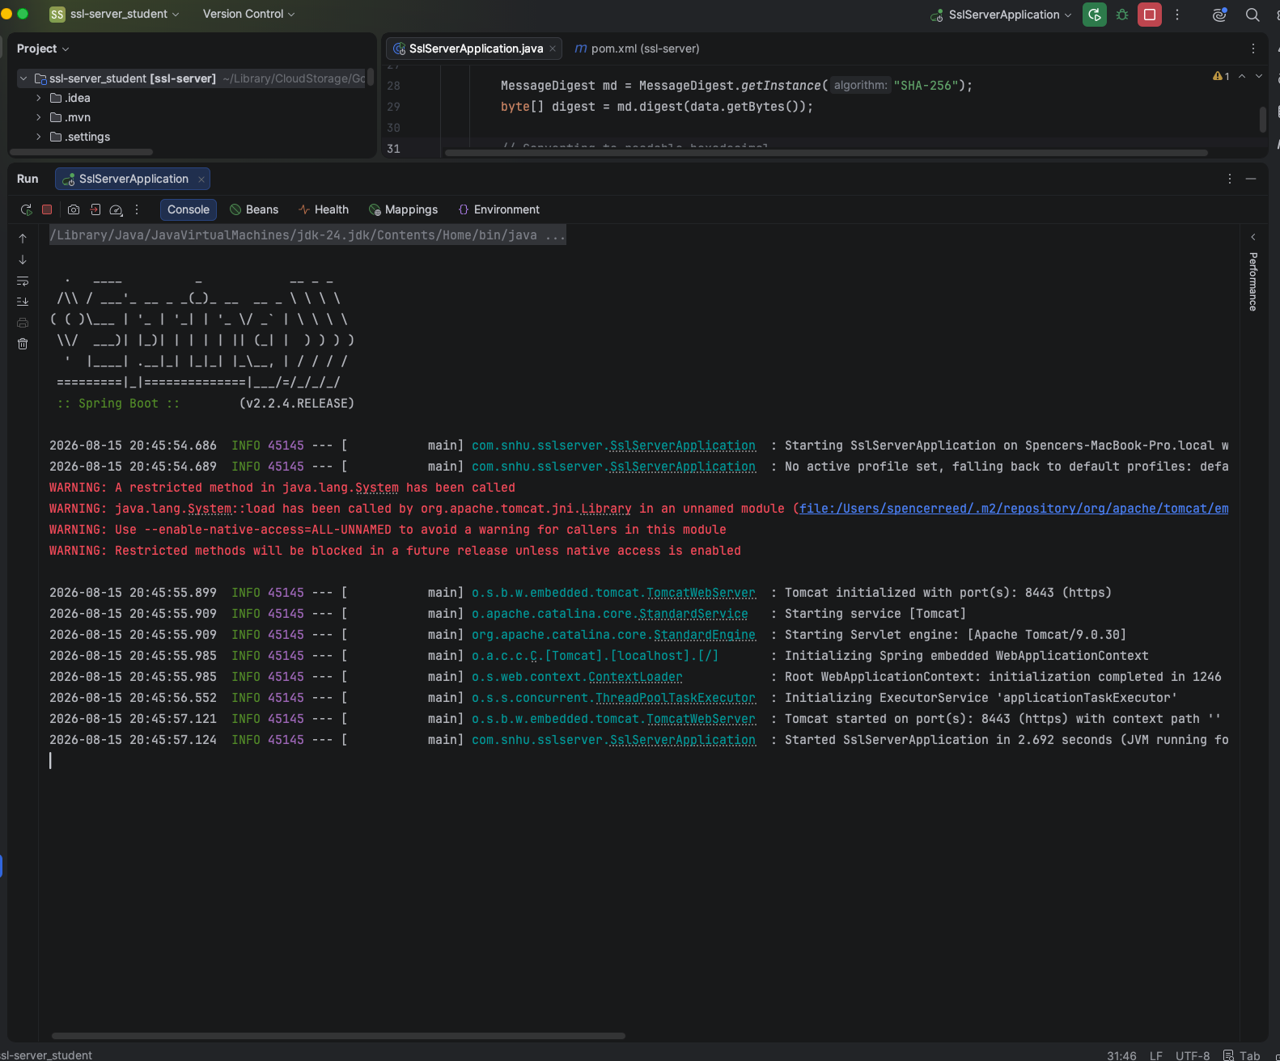

Summary

I did an architectural review by reviewing the code directly and running what was already available to see the errors that occurred. I ended up adding complementary layers: an integrity layer, an encryption-in-transit layer, and a verification layer. Each of these layers addresses a different part of the attack surface, so weakness in one spot is backed by the others. In refactoring the code for added security measures one of the biggest areas I targeted was the Cryptography (Encryption Use and Vulnerabilities) area. For this I added cryptographic integrity verification by utilizing the SHA-256 hash and enforced encryption in transit by converting from HTTP over to HTTPS/TLS. In addition, I handled the Client / Server (Secure Distributed Composing) area with refactoring the HTTP to HTTPS. This refactor secured the client-server communication channel and ensured data moving between the browser and the Spring Boot service is encrypted rather than be in plain text. I then ran a dependency-check for the static testing portion of the review to ensure no new vulnerabilities were introduced and confirmed that while the scan flagged known vulnerabilities in the inherited Spring Boot 2.2.4 framework libraries, my refactoring didn't introduce any new dependencies and therefore no new vulnerabilities.

Industry Standard Best Practices

By using Java's built-in MessageDigest library, I introduced no new third-party dependencies and therefore no new attack surface. I chose current, non-broken algorithms and protocols aligned with NIST guidance (SHA-256, RSA-2048, TLS) and re-ran static analysis to verify no regressions while keeping changes minimal and targeted to attack potentials. However, one thing to note here is that storing the plaintext keystore password in application.properties is generally advised against and remediated by utilizing environment variables or a secrets manager that doesn't get published with the code into production but can be used by the production server.

As Artemis Financial handles sensitive financial data this refactoring provides regulatory alignment with GLBA/FTC Safeguards rule, SOX, and PCI DSS. This enhances the reputation of the company and can reliably provide client trust as a competitive asset with confidence in securing client data at rest and in-transit. Preventing the attacks ahead of production is much cheaper than having to remediate a breach post go-live.

